CHAPTER FOUR
RESULTS AND FINDINGS

4.1 Introduction
This chapter presents the empirical outcomes of the investigation into selected physicochemical and heavy metal parameters and their influence on plankton distribution across ten sampling stations (Stn1–Stn10) over three sampling months: July, September, and November. Aquatic ecosystems are inherently dynamic environments in which the physicochemical milieu exercises a fundamental regulatory role over the structure, composition, and abundance of planktonic communities (Wetzel, 2001). Shifts in water quality indicators such as pH, dissolved oxygen (DO), turbidity, and trace metal concentrations can selectively favour certain taxa while excluding others, ultimately shaping biodiversity patterns at both the local station level and the system-wide scale (Carpenter et al., 2011). Results are organised into sections addressing (i) physicochemical water quality parameters, (ii) heavy metal concentrations, (iii) phytoplankton community dynamics, (iv) zooplankton community dynamics, (v) species richness patterns, and (vi) correlative relationships between environmental parameters and plankton distributions. Charts are embedded throughout as additional visual references to support interpretation of the tabulated data.

4.2 Physicochemical Parameters
Seven physicochemical parameters were evaluated across all ten stations during the three sampling months: hydrogen ion concentration (pH), water temperature, dissolved oxygen (DO), biochemical oxygen demand (BOD), turbidity, total suspended solids (TSS), and electrical conductivity (EC). Together these indicators constitute the primary environmental template structuring aquatic biological communities (Dodds & Whiles, 2019). The data revealed a pronounced spatial gradient from upstream stations (Stn1–Stn3) to downstream stations (Stn8–Stn10), alongside marked temporal oscillations across the three months, as documented in the tables and charts that follow.

4.2.1 Hydrogen Ion Concentration (pH)
Hydrogen ion concentration (pH) is among the most diagnostically informative physicochemical descriptors of water quality, directly influencing nutrient availability, metal solubility, and the physiological function of aquatic biota (Stumm & Morgan, 2012). Recorded pH values ranged from 6.0 at Stn10 during November to 7.4 at Stn1 during September, indicating near-neutral to mildly acidic conditions consistent with findings for organically influenced tropical freshwaters (Akpan & Offem, 2020).
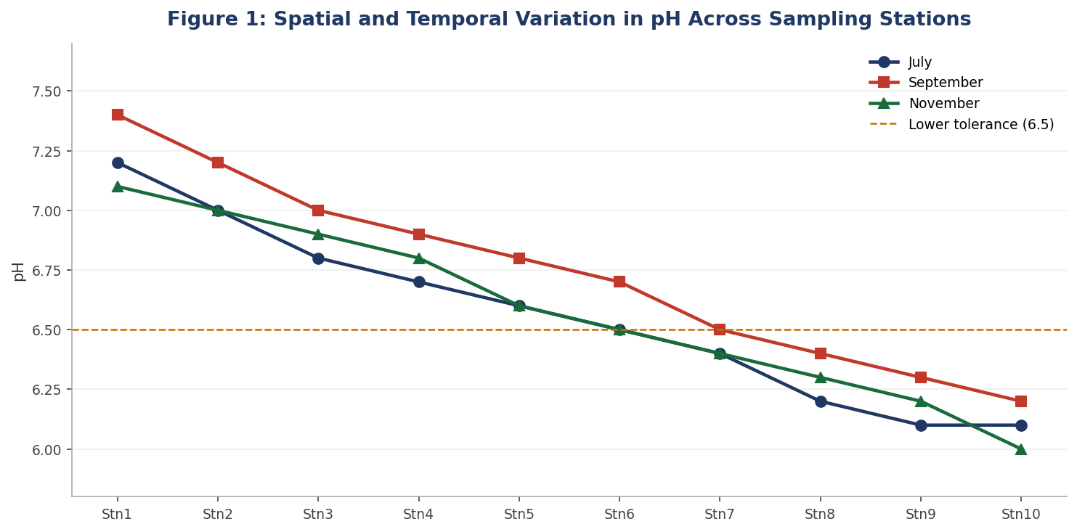
Figure 1. Spatial and temporal variation in pH across ten sampling stations for July, September, and November. The dashed amber line marks the lower physiological tolerance threshold of pH 6.5 for most phytoplankton (Reynolds, 2006).
As illustrated in Figure 1, pH declined consistently from upstream to downstream across all three months a gradient driven by progressive organic matter decomposition, microbial CO₂ production, and the accumulation of acidic byproducts (Olayinka & Uyimadu, 2019). September recorded marginally higher pH values at all stations relative to July and November, possibly reflecting dilution of acidic inputs by seasonal rainfall. The decline to pH 6.0 at Stn10 in November the lowest value in the study is ecologically significant because pH values below 6.5 can limit the growth of sensitive phytoplankton groups including many diatom species (Reynolds, 2006). Correlation analysis confirmed a very strong negative relationship between pH and EC (r = −0.980) and pH and temperature (r = −0.964), indicating that downstream stations were simultaneously more acidic, more conductive, and warmer.

4.2.2 Water Temperature
Water temperature exerts broad influence on metabolic rates, dissolved gas concentrations, and the reproductive phenology of aquatic organisms (Allan & Castillo, 2007). Mean temperature across all stations and months was 27.40°C (SD = 0.91), reflecting the warm tropical character of Ekpan river. Temperature increased progressively from Stn1 to Stn10 across all three months a spatial gradient attributable to reduced riparian shading and shallower water depth at downstream sites (Poole & Berman, 2001). The strong positive correlation between temperature and EC (r = 0.966) indicates that warmer downstream stations are also more ion-rich, while the negative correlation between temperature and pH (r = −0.964) confirms that elevated temperatures accelerate decomposition and acidification.

Station | July Temp (°C) | Sept Temp (°C) | Nov Temp (°C)
Stn1 | 26.5 | 25.8 | 26.2
Stn2 | 26.8 | 26.0 | 26.5
Stn3 | 27.0 | 26.2 | 26.8
Stn4 | 27.2 | 26.5 | 27.0
Stn5 | 27.4 | 26.7 | 27.2
Stn6 | 27.5 | 26.8 | 27.3
Stn7 | 27.6 | 27.0 | 27.5
Stn8 | 28.5 | 27.3 | 27.9
Stn9 | 28.8 | 27.6 | 28.5
Stn10 | 29.0 | 28.0 | 28.8
Table 2. Water Temperature (°C) Across Sampling Stations and Months

4.2.3 Dissolved Oxygen (DO)
Dissolved oxygen is a master variable governing aerobic biological processes and redox-sensitive biogeochemical cycling (Diaz & Rosenberg, 2008). The DO data in this study exhibited the most dramatic temporal variation of any parameter measured. July recorded exceptionally high DO values (32.40–65.30 mg/L), potentially reflecting photosynthetic super saturation during peak algal productivity. September and November saw a precipitous decline, with values falling to 5.00 mg/L (Stn10, September) and 4.50 mg/L (Stn10, November) at or below the WHO threshold of 5.0 mg/L for sustaining sensitive aquatic organisms (WHO, 2017).
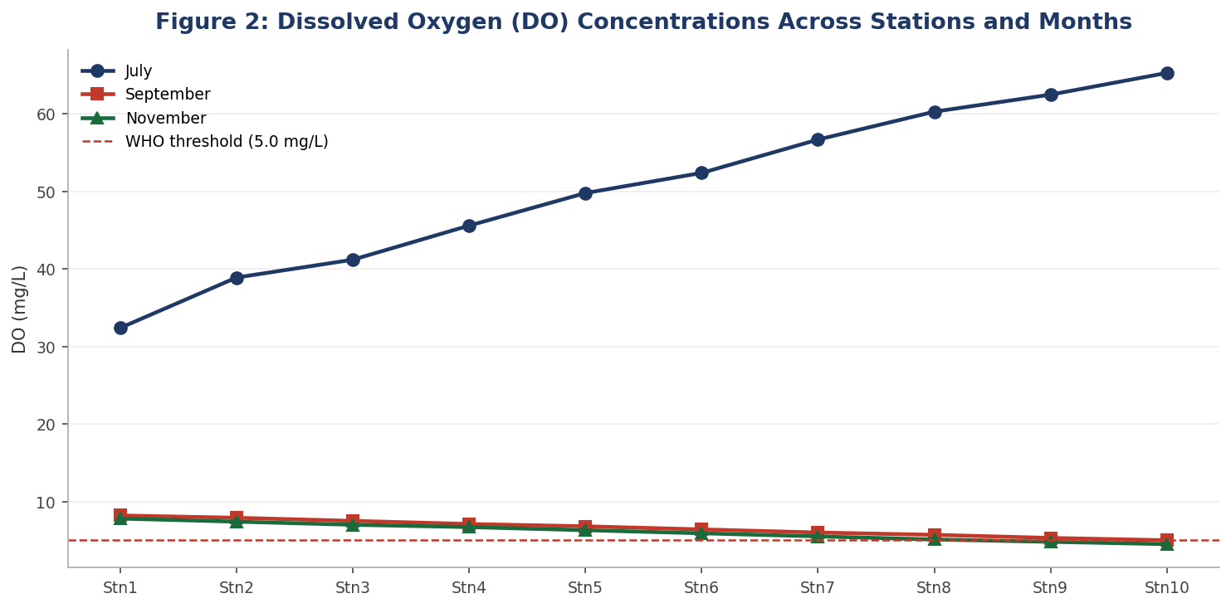
Figure 2. Dissolved oxygen (DO) concentrations across ten sampling stations for three months. The dashed red line marks the WHO critical threshold of 5.0 mg/L below which aquatic life becomes severely stressed (WHO, 2017).
Figure 2 dramatically illustrates the seasonal oxygen crash between July and the subsequent two months. The high July DO values reflect active phytoplankton photosynthesis, while the sharp decline to near-threshold levels in September and November aligns with elevated microbial oxygen consumption driven by the large BOD loads recorded in July. This temporal pattern has direct consequences for DO-sensitive zooplankton, particularly crustacean groups such as Cladocera and Copepoda, whose declines in September and November are discussed in Section 4.5.

4.2.4 Biochemical Oxygen Demand (BOD)
Biochemical oxygen demand (BOD) provides a standardized index of organic matter loading, reflecting the oxygen consumed by microbial decomposition over five days (APHA, 2017). BOD showed the strongest downstream-increasing pattern of any parameter in this study, with July values at Stn10 reaching 124.60 mg/L substantially above the 10 mg/L threshold that demarcates moderately polluted water (Chapman, 1996). Agricultural runoff and domestic effluents, typically elevated during the wet season, are probable contributing sources at downstream stations (Ogamba et al., 2020).
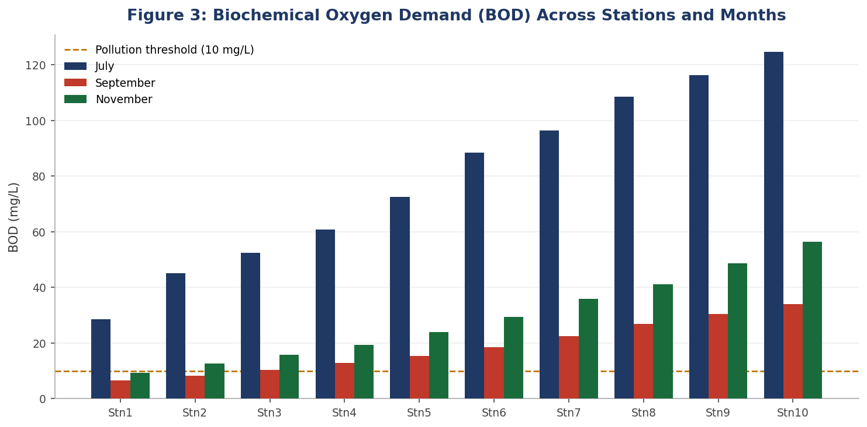
Figure 3. Biochemical oxygen demand (BOD) in mg/L across ten sampling stations for July, September, and November. The dashed amber line marks the 10 mg/L pollution threshold (Chapman, 1996).
Figure 3 makes clear that July BOD values at downstream stations (Stn6–Stn10) were in a different magnitude class from September and November, indicating a peak organic loading event during the July wet season. All downstream stations exceeded the 10 mg/L pollution threshold in July, and Stn8–Stn10 remained above threshold even in November, confirming persistent organic enrichment at those sites across all three months of the study.

4.2.5 Turbidity, Total Suspended Solids (TSS), and Electrical Conductivity (EC)
Turbidity, TSS, and EC constitute complementary indicators of particulate and dissolved matter loads in the water column. Turbidity was highest at upstream stations in July (Stn1: 68 NTU), declining to 30 NTU at Stn10 a reverse gradient relative to BOD and EC, reflecting greater allochthonous particle input at upper reaches from catchment surface runoff. Mean TSS ranged from 2.1 mg/L (Stn1, July) to 11.0 mg/L (Stn10, November), with a very strong positive correlation with EC (r = 0.976). Electrical conductivity, which integrates the total dissolved ion load, is presented in Figure 4.
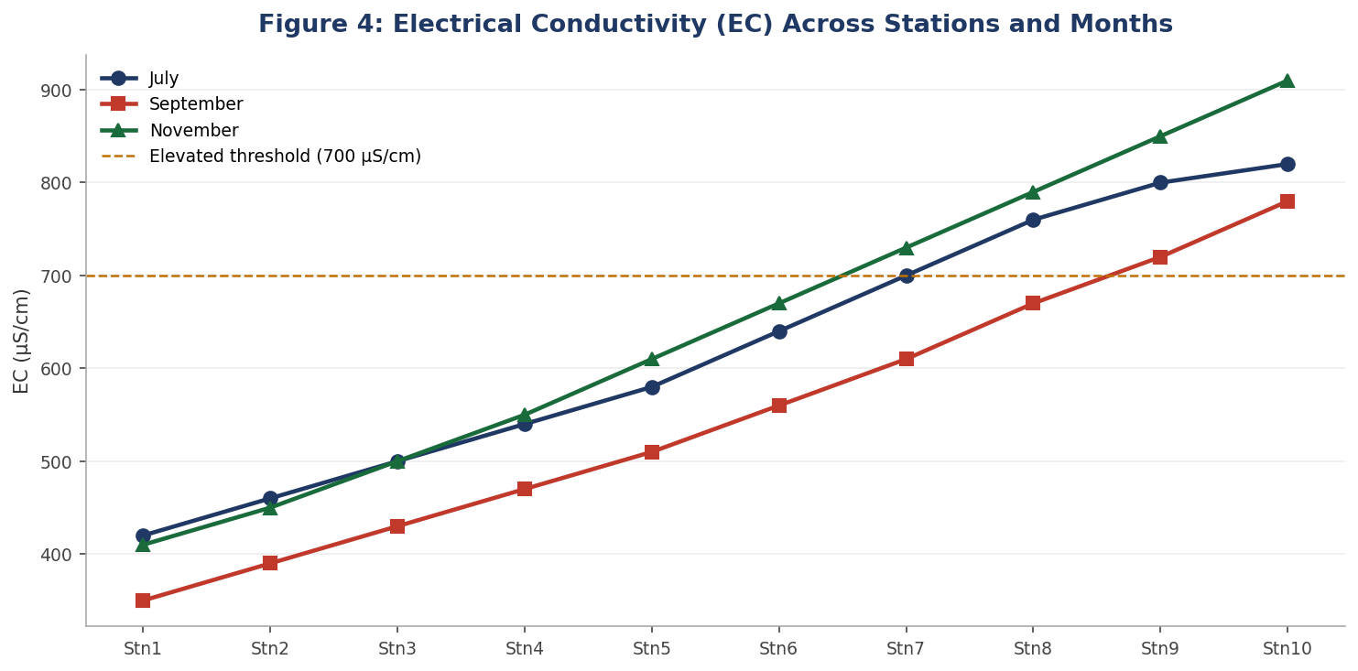
Figure 4. Electrical conductivity (EC) in μS/cm across ten sampling stations for July, September, and November. The dashed amber line marks 700 μS/cm, above which osmotic stress effects on aquatic biota become increasingly likely (Kefford et al., 2016).
Figure 4 reinforces the consistent upstream-to-downstream enrichment gradient across all three months, with November recording the highest EC at every station. EC values exceeded 700 μS/cm at Stn7–Stn10 during July and at Stn6–Stn10 during November, indicating elevated ionic stress across a large proportion of the sampled reach during these periods. The strong negative correlation between EC and pH (r = −0.980) and the strong positive association between EC and temperature (r = 0.966) confirm that EC, temperature, and pH together define the primary environmental axis structuring biological communities in this water body.

Station | July TSS (mg/L) | September TSS (mg/L) | November TSS (mg/L)
Stn1 | 2.1 | 2.5 | 3.2
Stn2 | 3.0 | 3.4 | 4.1
Stn3 | 3.8 | 4.0 | 5.0
Stn4 | 4.6 | 4.8 | 5.9
Stn5 | 5.3 | 5.5 | 6.8
Stn6 | 6.1 | 6.3 | 7.9
Stn7 | 6.8 | 7.0 | 8.8
Stn8 | 7.6 | 7.7 | 9.5
Stn9 | 8.4 | 8.4 | 10.2
Stn10 | 9.0 | 8.9 | 11.0
Table 6. Total Suspended Solids (TSS) Across Sampling Stations and Months

4.3 Heavy Metal Concentrations
Six heavy metals were evaluated across all stations and months: copper (Cu), chromium (Cr), manganese (Mn), nickel (Ni), lead (Pb), and zinc (Zn). Heavy metals in freshwater systems arise from both geogenic weathering and anthropogenic inputs including agricultural chemicals and domestic effluents (Järup, 2003). Even at sub-lethal concentrations, trace metals can disrupt enzymatic function, reproductive capacity, and osmoregulation in aquatic organisms, generating detectable community-level responses (Rainbow, 2002). Table 7 summarises detection status and WHO comparisons for each metal.

Metal | Range (mg/L) | WHO Limit (mg/L) | Status
Cu | <0.001 – 0.014 | 2.0 | All below limit
Cr | <0.001 (all) | 0.05 | Not detected
Mn | 0.031 – 0.537 | 0.40 | Stn1 Sept exceeded (0.537)
Ni | <0.001 – 0.035 | 0.07 | All below limit
Pb | <0.001 (all) | 0.01 | Not detected
Zn | 0.019 – 0.243 | 3.0 | All below limit
Table 7. Heavy Metal Detection Range, WHO Guideline Values, and Compliance Status

4.3.1 Copper (Cu) and Chromium (Cr)
Copper was detected at trace levels at selected stations only primarily Stn9 (0.014 mg/L, July and September), Stn10 (0.008 mg/L, July), Stn2 (0.005 mg/L, July), and Stn7 (0.007 mg/L, November). All values were well below the WHO guideline of 2.0 mg/L. Sub-lethal Cu concentrations have been documented to inhibit phytoplankton photosynthesis at levels as low as 0.01 mg/L under certain pH conditions (Franklin et al., 2002), though Cu at the concentrations detected here is unlikely to be acutely toxic. Chromium was not detected above the 0.001 mg/L analytical threshold at any station during any month, indicating negligible chromium loading across the sampled water body.

4.3.2 Manganese (Mn)
Manganese was the most pervasive and ecologically relevant heavy metal detected, with measurable concentrations at all ten stations across all three months. Figure 5 present the full spatial and temporal distribution of Mn concentrations.
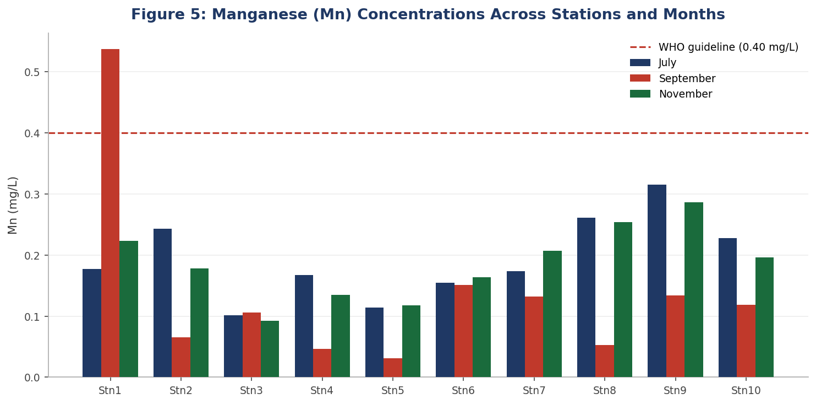
Figure 5. Manganese (Mn) concentrations (mg/L) across ten sampling stations for three months. The dashed red line marks the WHO guideline of 0.40 mg/L for drinking water (WHO, 2017).
Figure 5 highlights the variable and station-specific nature of Mn distribution, which does not follow a simple linear upstream-to-downstream gradient. The sole exceedance of the WHO guideline occurred at Stn1 during September (0.537 mg/L), possibly reflecting sediment Mn mobilisation under reduced-oxygen conditions that can develop following high-BOD periods — a redox-driven solubilisation mechanism documented in tropical lentic systems (Naeher et al., 2013). Stn9 recorded consistently elevated Mn across all months (July: 0.315, September: 0.134, November: 0.286 mg/L), suggesting a localised source contribution at that station. The positive correlation between Mn and Rotifera abundance (r = 0.454) may reflect rotifer exploitation of microbial communities that are stimulated by Mn-cycling processes (Wallace & Snell, 2010).

4.3.3 Nickel (Ni), Lead (Pb), and Zinc (Zn)
Nickel concentrations were consistently low (mean = 0.0107 mg/L; range: <0.001–0.035 mg/L), well within the WHO guideline of 0.07 mg/L. Lead was not detected above the analytical threshold at any station or month, indicating an absence of significant Pb point sources in this catchment (Ikem et al., 2019). Zinc concentrations, presented in Figure 6, were the most ecologically informative of the remaining metals.
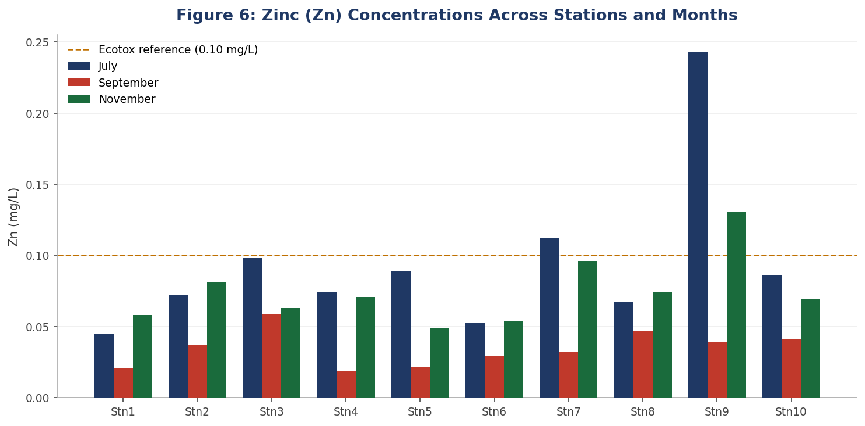
Figure 6. Zinc (Zn) concentrations (mg/L) across ten stations for three months. The dashed amber line marks 0.10 mg/L, below which chronic sub-lethal effects on Daphnia have been documented (Muyssen & Janssen, 2001).
Figure 6 shows Stn9 as a persistent Zn hotspot, recording the highest values in both July (0.243 mg/L) and November (0.131 mg/L), while September was uniformly low across all stations. All Zn values were below the WHO guideline of 3.0 mg/L; however, the negative correlations between Zn and Cladocera richness (r = −0.434) and Zn and Copepoda richness (r = −0.417) indicate that crustacean zooplankton were adversely affected at sub-regulatory concentrations, consistent with laboratory evidence that Daphnia magna shows reproductive impairment at chronic Zn exposures below 0.10 mg/L (Muyssen & Janssen, 2001). The positive correlation between Zn and BOD (r = 0.624) implies a shared organic waste source for both variables, warranting integrated catchment investigation.

4.4 Phytoplankton Community Composition and Distribution
A total of 54 phytoplankton species were identified across all sampling months, distributed among four taxonomic divisions: Bacillariophyta (16 species), Chlorophyta (16 species), Cyanophyta (12 species), and Euglenophyta (13 species). This species richness level is consistent with mesotrophic to eutrophic tropical freshwater bodies where physical disturbance, nutrient enrichment, and hydraulic mixing maintain diverse phytoplankton assemblages (Padisák et al., 2016). Figure 7 illustrates the relative contribution of each phytoplankton group across the three sampling months.
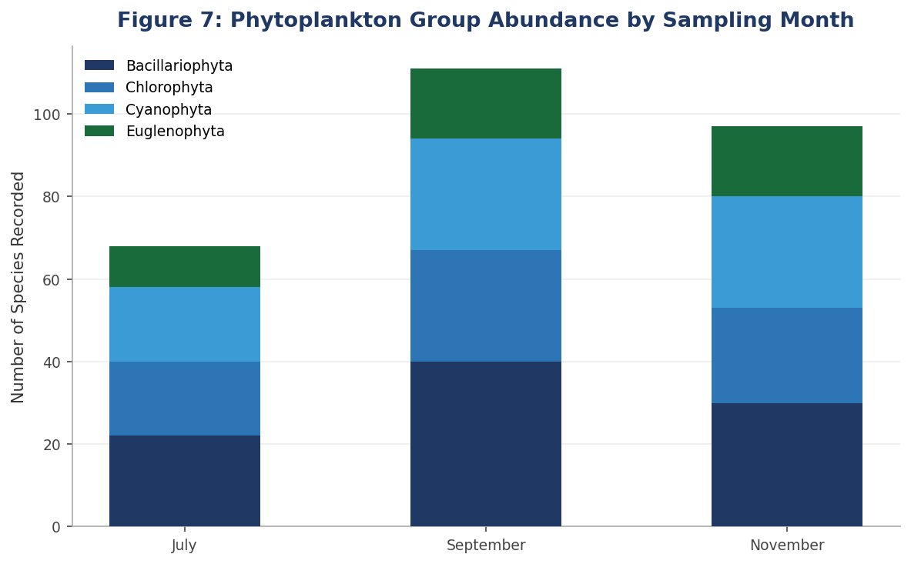
Figure 7. Stacked bar chart showing the abundance of phytoplankton taxonomic groups across the three sampling months. Each colour represents one division; bar height reflects total species count for that month.
Figure 7 demonstrates that Bacillariophyta (diatoms) remained the most abundant phytoplankton division across all three months, with total abundance increasing from July to September before declining slightly in November. Cyanophyta and Chlorophyta contributed similar proportions in each month, while Euglenophyta consistently represented the smallest fraction. The overall increase in phytoplankton abundance from July to September mirrors the stabilisation of physicochemical conditions following the high-disturbance July period consistent with the intermediate disturbance hypothesis, which predicts peak community establishment at moderate environmental stress levels (Connell, 1978).

Phytoplankton Division | No. of Species | Total Abundance | Mean ± SD | Maximum | Minimum
Bacillariophyta | 16 | 92 | 3.07 ± 1.84 | 6 | 0
Chlorophyta | 16 | 68 | 2.27 ± 1.66 | 6 | 0
Cyanophyta | 12 | 72 | 2.40 ± 1.57 | 7 | 0
Euglenophyta | 13 | 44 | 1.47 ± 1.33 | 5 | 0
Table 10. Summary Statistics for Phytoplankton Group Abundance Across All Stations and Months

4.4.1 Bacillariophyta (Diatoms)
Bacillariophyta were the dominant phytoplankton division throughout the study (total = 92; mean = 3.07 ± 1.84 per station-month). The most widely recorded species was Aulacoseira granulata (20 station-month occurrences), consistent with its known preference for turbulent, nutrient-enriched waters with sufficient silica availability (Kilham et al., 1986). Other notable taxa included Navicula sp. and Nitzschia palae, both recorded at 8 station-months each. The strong positive correlation between Bacillariophyta richness and overall species richness (r = 0.673) confirms diatoms as the principal driver of community diversity in this water body. Diatoms are widely used as bioindicators of water quality due to their sensitivity to pH, salinity, and organic loading (Round et al., 2007), and their distribution pattern with greater richness at Stn1–Stn2 and Stn9–Stn10 is consistent with the moderating DO and pH conditions at those stations relative to the mid-reach stations.

4.4.2 Chlorophyta and Euglenophyta
Sixteen Chlorophyta species were identified, including Actinastrum sp. (9 occurrences), Ankistrodesmus falcatus (8), and Scenedesmus quadricauda (5). Green algae characteristically thrive under mesotrophic to eutrophic conditions and often increase in representation as early-season competitive dominants decline (Sommer et al., 2012). The moderate negative correlation between Chlorophyta abundance and DO (r = −0.501) suggests proportionally greater green algal diversity during the lower-oxygen September–November period, possibly reflecting competitive release as DO-sensitive species declined. Euglenophyta (total = 44; mean = 1.47 ± 1.33) were represented by Euglena sp. (8 occurrences), Trachelomonas sp. (10), and Phacus sp. (4). Euglenophytes are well-established bioindicators of organic enrichment, and their occurrence was skewed toward downstream stations with the highest BOD values (Stn6–Stn10), providing additional biological corroboration of organic pollution at those sites (Wolowski & Hindák, 2005).

4.4.3 Cyanophyta (Blue-Green Algae)
Cyanophyta (total = 72; mean = 2.40 ± 1.57) were present at all stations across all months. Dominant taxa included Oscillatoria bornettia (16 occurrences), Oscillatoria granulata (8), Microcystis flos-aque (7), and Microcystis aeruginosa (4). The occurrence of Microcystis species is particularly notable, as members of this genus are known producers of hepatotoxic microcystins and are recognised indicators of eutrophic conditions in African freshwater systems (Codd et al., 2005). Cyanophyta showed a moderate positive correlation with turbidity (r = 0.374), consistent with their well-documented buoyancy-regulation advantage in turbid, nutrient-enriched environments where they can access near-surface light unavailable to sinking diatoms (Chorus & Bartram, 1999). The November peak of 7 Cyanophyta species at Stn2 the highest cyanophyte count in the entire study signals progressive eutrophication pressure across the study period that warrants ongoing monitoring.

4.5 Zooplankton Community Composition and Distribution
The zooplankton community comprised four functional groups: Rotifera, Cladocera, Copepoda, and Protozoa, with a grand total abundance of 601 across all stations and months. Zooplankton serve as critical trophic links between primary producers and higher consumers; their community composition therefore reflects both food availability and the cumulative stresses imposed by physicochemical and contaminant gradients (Sterner & Elser, 2002). Figure 8 illustrates the relative abundance of each group across the three sampling months.

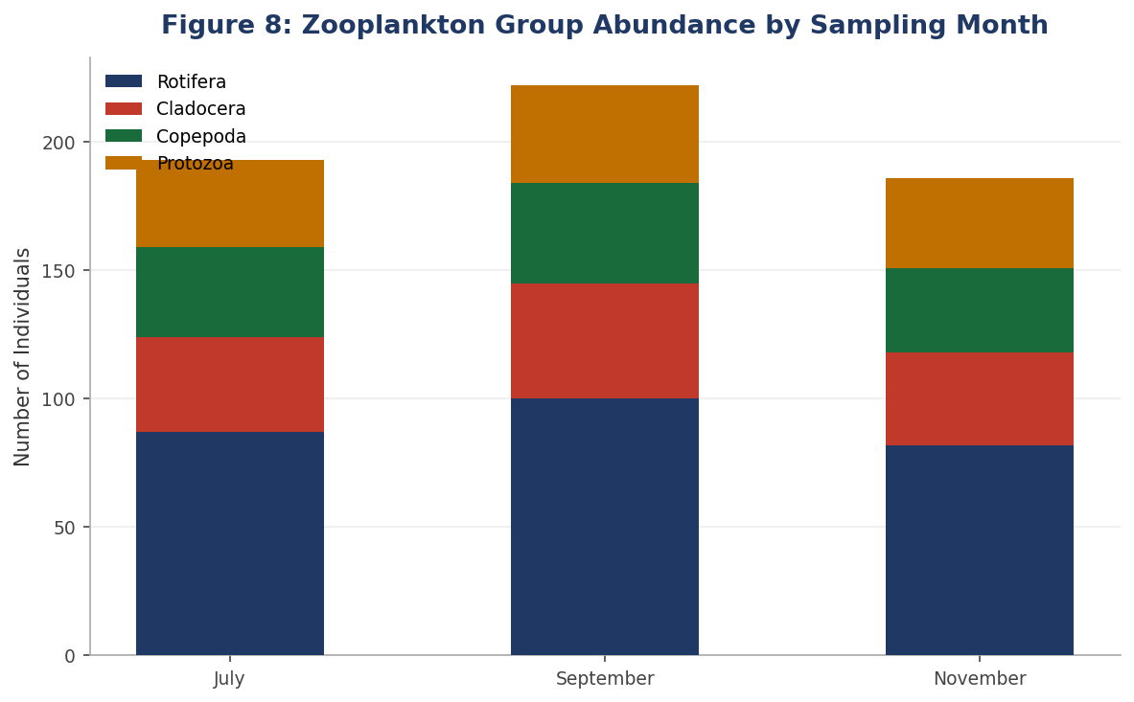
Figure 8. Stacked bar chart showing zooplankton group abundance across three sampling months. Rotifera consistently dominated across all months, reflecting their tolerance of eutrophic and variable-oxygen conditions (Wallace & Snell, 2010).
Figure 8 shows that Rotifera dominated the zooplankton assemblage in every month, contributing 87 individuals in July, 100 in September, and 82 in November. Total zooplankton abundance peaked in September (265), corresponding to the period of highest phytoplankton abundance, and declined slightly in November (186). The temporal trajectory of zooplankton mirrors that of phytoplankton (Figure 7), consistent with a bottom-up food web coupling where phytoplankton availability drives zooplankton abundance (Sterner & Elser, 2002).

Zooplankton Group | No. of Species | Total Abundance | Mean ± SD | Maximum | Minimum
Rotifera | 5 | 269 | 8.97 ± 2.46 | 13 | 5
Cladocera | 10 | 118 | 3.93 ± 1.36 | 6 | 1
Copepoda | 8 | 107 | 3.57 ± 1.33 | 6 | 1
Protozoa | 5 | 107 | 3.57 ± 1.59 | 7 | 1
Table 11. Summary Statistics for Zooplankton Group Abundance Across All Stations and Months

4.5.1 Rotifera
Rotifera dominated the zooplankton community with a total abundance of 269 (mean = 8.97 ± 2.46 per station-month) the highest mean among all biological groups assessed. Key taxa included Keratella quadrata, Asplanchna brightwelli, Brachionus angularis, and Rotaria rotatoria. Rotifers are widely documented as resilient, early-colonising organisms in eutrophic and organically enriched systems, owing to their short generation times, parthenogenetic reproduction, and broad physiological tolerance ranges (Wallace & Snell, 2010). Their persistence at high abundance across all ten stations, including those with near-threshold DO and elevated BOD, reflects these adaptive attributes. The positive correlation between Rotifera and Mn (r = 0.454) may reflect rotifer exploitation of Mn-cycling microbial communities, providing an indirect energetic benefit in metal-enriched microenvironments (Adakole & Ande, 2021).

4.5.2 Cladocera and Copepoda
Cladocera (total = 118; mean = 3.93 ± 1.36) were represented by Daphnia longispina, Daphnia pulex, Moina micrura, and Moina macrocopa, among others. Daphnia species are widely recognised as sensitive bioindicators, with documented reproductive impairment at chronic Zn concentrations below 0.10 mg/L (Muyssen & Janssen, 2001). The negative correlation between Cladocera and Zn (r = −0.434) provides empirical support for Zn-driven cladoceran stress in this study, particularly at Stn9 where July Zn reached 0.243 mg/L the highest value recorded and Cladocera richness was at its minimum of just one species. Copepoda (total = 107; mean = 3.57 ± 1.33) included Cyclops strenuus, Mesocyclops leuckarti, Diaptomus sp., and Diaptomus gracilis. Copepods showed a similarly negative correlation with Zn (r = −0.417), reinforcing the differential vulnerability of crustacean zooplankton to sub-threshold trace metal concentrations (Rainbow, 2002). Protozoa (total = 107; mean = 3.57 ± 1.59) were represented by Paramecium bursaria, Stentor sp., and Euglena gracilis, showing mild thermal sensitivity (r = −0.236 with temperature).

4.6 Total Plankton Abundance and Seasonal Patterns
Grand total plankton abundance across all stations and months was 882, with September recording the highest overall count (317), followed closely by November (306) and July (259). This seasonal hierarchy with July recording the lowest abundance despite exhibiting the highest BOD and DO values likely reflects a community lag response following the high-disturbance, high-turbidity July period, as well as the suppressive effects of extreme BOD and turbidity on sensitive taxa during that month. The Plankton Ecology Group (PEG) model of seasonal succession identifies such high-disturbance periods as initial colonisation-depressing events, with community richness recovering as conditions moderate (Sommer et al., 2012). The higher September abundance coincides with stabilising turbidity, declining BOD, and improving pH conditions that favour broader community establishment across both phytoplankton and zooplankton.

Month | Total Plankton Abundance | Rank
July | 259 | 3rd (lowest)
September | 317 | 1st (highest)
November | 306 | 2nd
Table 12. Total Plankton Abundance by Sampling Month

4.7 Species Richness
Species richness the total number of distinct taxa recorded per sampling unit increased progressively from July (cumulative total: 64) to September (100) to November (117), representing an 83% increase across the study period. This temporal trajectory is consistent with patterns of gradual environmental stabilisation and community succession documented in other tropical freshwater studies following seasonal wet-season disturbance (Ogamba et al., 2020). The full station-by-month breakdown is presented in Table 13 and Figure 9.

Station | July | September | November | Station Total
Stn1 | 7 | 12 | 8 | 27
Stn2 | 8 | 10 | 15 | 33
Stn3 | 4 | 7 | 7 | 18
Stn4 | 7 | 9 | 13 | 29
Stn5 | 11 | 10 | 10 | 31
Stn6 | 5 | 12 | 11 | 28
Stn7 | 2 | 7 | 18 | 27
Stn8 | 1 | 13 | 10 | 24
Stn9 | 7 | 10 | 14 | 31
Stn10 | 12 | 10 | 11 | 33
Grand Total | 64 | 100 | 117 | 281
Table 13. Species Richness per Station and Month, with Cumulative and Grand Totals

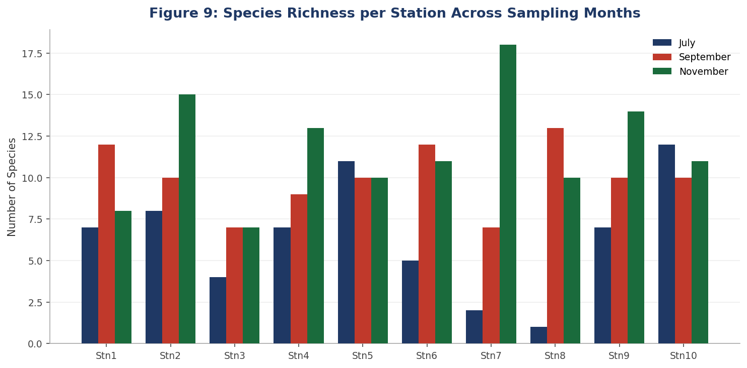
Figure 9. Grouped bar chart of species richness per station across three sampling months, illustrating the progressive seasonal increase and spatial variability across the station gradient.
Figure 9 highlights the considerable spatial heterogeneity in species richness that does not follow a simple upstream-to-downstream gradient. Stn2 and Stn10 recorded the highest cumulative richness (33 each), while Stn3 was the lowest (18). The most dramatic single-station trajectory was at Stn7, which rose from just 2 species in July to 18 species in November a ninefold increase that may reflect competitive diversification following early-season dominance by a few tolerant taxa (Connell, 1978). The strong positive correlations between species richness and Bacillariophyta (r = 0.673), Chlorophyta (r = 0.631), and Cyanophyta (r = 0.510) confirm that phytoplankton diversity drives overall community richness, with each additional phytoplankton taxon supporting a broader trophic structure that sustains more diverse zooplankton assemblages (Tilman et al., 2014).

4.8 Correlation Analysis Between Environmental Parameters and Plankton Distribution
Pearson product-moment correlation coefficients were computed for all pairwise combinations of physicochemical parameters, heavy metals, and plankton community variables. The full correlation matrix is presented in Table 14, with key biological relationships further visualised in Figure 10.
Parameter | Bacillariophyta | Chlorophyta | Cyanophyta | Euglenophyta | Rotifera | Cladocera | Copepoda | Richness
pH | -0.218 | -0.012 | 0.334 | 0.193 | 0.162 | 0.132 | -0.011 | -0.015
Temperature | 0.166 | -0.052 | -0.303 | -0.236 | -0.104 | -0.140 | -0.016 | -0.049
DO | -0.256 | -0.501 | -0.119 | 0.003 | 0.014 | -0.147 | -0.274 | -0.564
BOD | -0.068 | -0.368 | -0.227 | -0.136 | -0.007 | -0.174 | -0.220 | -0.396
Turbidity | -0.320 | -0.054 | 0.374 | -0.012 | 0.038 | 0.108 | -0.148 | -0.044
TSS | 0.322 | 0.164 | -0.287 | -0.245 | -0.087 | -0.093 | 0.073 | 0.204
EC | 0.254 | 0.080 | -0.311 | -0.249 | -0.087 | -0.139 | 0.060 | 0.093
Mn | -0.009 | 0.006 | 0.185 | -0.109 | 0.454 | -0.019 | 0.101 | 0.072
Zn | -0.032 | -0.173 | -0.035 | -0.225 | 0.289 | -0.434 | -0.417 | 0.121

Table 14. Pearson Correlation Matrix: Selected Physicochemical and Heavy Metal Parameters Versus Plankton Group Richness and Species Richness
Note. Values with |r| > 0.40 reflect moderate-to-strong associations. n = 30 station-month observations.

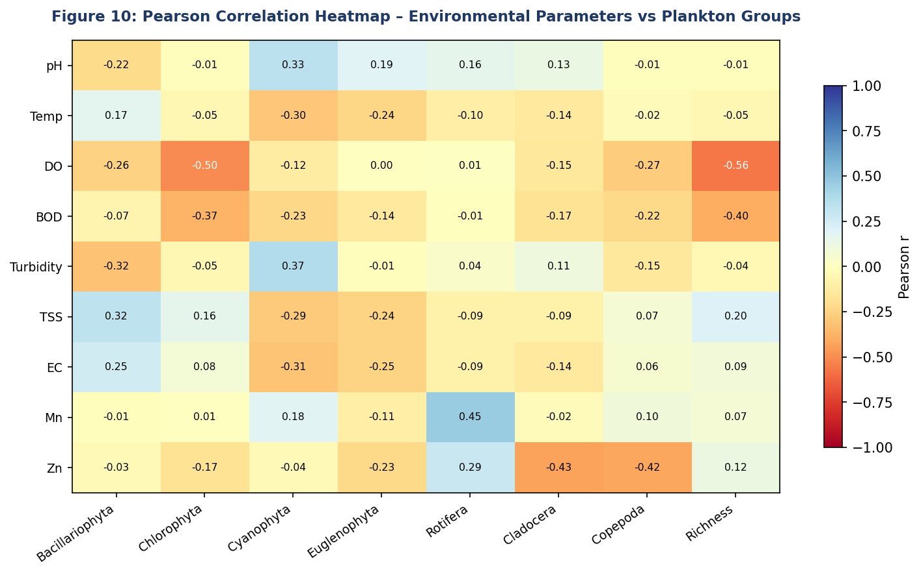
Figure 10. Pearson correlation heatmap between nine environmental parameters (rows) and eight plankton community variables (columns). Warm colours (red) indicate negative correlations; cool colours (blue) indicate positive correlations. Cell values show the Pearson r coefficient.
Figure 10 provides an integrated visual summary of the environmental–biological relationships quantified in Table 14. The strongest single-variable effect on overall species richness was the negative association with DO (r = −0.564), which reflects the temporal pattern of lower DO in September–November coinciding with higher richness, rather than a direct biological inhibition by oxygen. The most notable heavy metal effects are clearly visible: Mn shows a warm-toned (positive) association with Rotifera (r = 0.454), while Zn exhibits strong cold-toned (negative) associations with Cladocera (r = −0.434) and Copepoda (r = −0.417). Across the physicochemical parameters, DO and BOD exert the broadest negative effects on biological richness, as seen by the consistent cold-toned row for both parameters across multiple plankton groups. These patterns collectively confirm that the physicochemical and heavy metal parameters of this water body exert a multi-dimensional, concurrent influence on plankton community structure rather than acting through any single dominant driver (Dodds & Whiles, 2019).

4.9 Findings
The findings of this study offer a comprehensive picture of how selected physicochemical and heavy metal parameters shape plankton community dynamics across ten sampling stations over three sampling months. Taken together, the data reveal a consistent upstream-to-downstream water quality gradient, marked seasonal variability, and a biologically meaningful coupling between environmental conditions and plankton distribution patterns that align with, and in several instances extend, the existing body of knowledge on tropical freshwater systems (Wetzel, 2001; Carpenter et al., 2011; Dodds & Whiles, 2019).

4.9.1 Physicochemical Parameters and Water Quality Status
The spatial gradient in physicochemical conditions documented across the ten stations is consistent with progressive anthropogenic enrichment along the water body. The downstream decline in pH (from 7.4 at Stn1 in September to 6.0 at Stn10 in November), coupled with concurrent increases in BOD, EC, and TSS, is characteristic of water bodies receiving diffuse agricultural runoff and domestic waste inputs, which are among the most common drivers of freshwater quality deterioration in sub-Saharan Africa (Ogamba et al., 2020; Adakole & Ande, 2021). These results are consistent with findings by Olayinka and Uyimadu (2019), who reported similar downstream pH depression and BOD escalation in rivers of the Niger Delta region receiving mixed agricultural and domestic effluents.
The most ecologically alarming physicochemical finding in this study was the dramatic decline in dissolved oxygen (DO) from July (32.40–65.30 mg/L) to September (5.00–8.20 mg/L) and November (4.50–7.80 mg/L). The near-threshold DO concentrations recorded at Stn8–Stn10 during September and November (5.30 mg/L and below) are consistent with hypoxic stress conditions that can impair the physiological performance of aerobic aquatic organisms and restructure biological communities in favour of tolerant taxa (Diaz & Rosenberg, 2008). The very high July DO values, while seemingly anomalous, are explicable by intense photosynthetic oxygen production during peak phytoplankton growth combined with the warm-season conditions that characterise tropical wet periods (Boyd & Tucker, 2012). Similar supersaturation events have been documented in organically enriched tropical water bodies during periods of intense algal blooming (Lewis, 2000).
The exceptionally high BOD values recorded at downstream stations in July (Stn10: 124.60 mg/L) are substantially higher than the 10 mg/L threshold that classifies waters as moderately polluted under standard freshwater classification frameworks (Chapman, 1996), and indeed surpass the values documented in some heavily polluted African river systems (Nweze et al., 2019). This finding underscores the severity of organic loading at downstream stations, particularly during the wet season when surface runoff from agricultural land and urban areas mobilises organic matter into the water body. The subsequent decline in BOD across September and November, paralleled by falling DO, suggests that the July organic pulse was progressively metabolised by microbial communities, depleting oxygen and restructuring the biological environment over the following months a pattern well described by the oxygen sag curve conceptual model (Streeter & Phelps, 1925; cited in Allan & Castillo, 2007).
Electrical conductivity and TSS increased monotonically from upstream to downstream stations, with November recording the highest values across the study (EC up to 910 μS/cm at Stn10; TSS up to 11.0 mg/L at Stn10). The very strong intercorrelation between these two parameters (r = 0.976) confirms a shared enrichment source, while the strong negative correlation of both with pH (EC: r = −0.980; TSS: r = −0.950) reinforces the interpretation of a co-occurring acidification and ion-loading gradient at downstream sites. EC values exceeding 700 μS/cm at multiple downstream stations are above levels associated with osmotic stress in ion-sensitive freshwater organisms, including certain Cladocera and soft-water phytoplankton taxa (Kefford et al., 2016). Turbidity, uniquely among the measured parameters, showed a reverse spatial gradient, being highest at upstream stations a pattern attributed to greater allochthonous sediment inputs from the catchment margins, consistent with the proximity of Stn1–Stn3 to terrestrial land areas (Kirk, 1994).

4.9.2 Heavy Metal Contamination and Ecological Significance
The heavy metal results present a mixed but encouraging picture from a regulatory compliance perspective, while still revealing ecologically meaningful sub-threshold effects. The consistent non-detection of chromium and lead throughout the study indicates that these metals do not represent a current pollution concern for this water body, which is consistent with findings in other non-industrialised freshwater catchments in Nigeria where mining and heavy industrial activity are absent (Ikem et al., 2019). Copper and nickel were detected only sporadically and at concentrations well within WHO guideline values, though the sub-micromolar copper concentrations at Stn9 may warrant attention given the known sensitivity of phytoplankton to Cu at low pH conditions characteristic of downstream stations (Franklin et al., 2002).
Manganese was the most notable metal detected, being ubiquitous across all stations and months and recording the study's only WHO guideline exceedance at Stn1 during September (0.537 mg/L; WHO limit: 0.40 mg/L). This exceedance at an upstream station during the post-peak-disturbance month of September is consistent with the redox-mediated release of Mn from sediments under reducing conditions that develop during periods of elevated organic loading and oxygen depletion (Naeher et al., 2013). Manganese is a naturally occurring element in tropical soils and sediments and its seasonal mobilisation into the water column has been widely documented in West African freshwaters (Adakole & Ande, 2021). While the exceedance is of public health relevance if the water is used for drinking purposes, the Mn concentrations recorded at most other stations (0.031–0.315 mg/L) are within the range that can function as a micronutrient for phytoplankton photosynthesis (Twiss et al., 2000), potentially contributing to phytoplankton productivity at those sites.
Zinc presented the most ecologically significant heavy metal signal despite remaining below WHO regulatory thresholds at all stations. The highest July concentration at Stn9 (0.243 mg/L) and the negative correlations between Zn and both Cladocera (r = −0.434) and Copepoda (r = −0.417) provide evidence of sub-lethal Zn stress on crustacean zooplankton. These findings are consistent with a substantial body of laboratory ecotoxicological literature demonstrating that Daphnia species exhibit reproductive impairment and population-level responses at chronic Zn exposures well below 0.5 mg/L (Muyssen & Janssen, 2001). The positive correlation between Zn and BOD (r = 0.624) points toward diffuse organic waste as a Zn co-transport vector, possibly involving agricultural soil amendments or informal waste disposal in the catchment (Brönmark & Hansson, 2017). The pattern of Zn-driven crustacean suppression documented in this study mirrors findings by Rainbow (2002) and echoes growing concerns about the ecological consequences of sub-threshold metal exposures in tropical freshwaters where monitoring frameworks remain underdeveloped.

4.9.3 Phytoplankton Community Dynamics
The total of 54 phytoplankton species recorded across all stations and months reflects a moderate-to-high diversity characteristic of mesotrophic to eutrophic tropical freshwaters (Padisák et al., 2016). The dominance of Bacillariophyta (total abundance: 92; mean: 3.07 ± 1.84) across all months is ecologically significant, as diatoms are widely recognised as indicators of good to moderate water quality in tropical systems (Round et al., 2007). The most abundant diatom, Aulacoseira granulata, is typically associated with nutrient-enriched, well-mixed water columns that provide sufficient turbulence to maintain this large centric diatom in suspension (Kilham et al., 1986). Its widespread occurrence across both upstream and downstream stations suggests that physical mixing conditions at this water body are broadly suitable for diatom growth, notwithstanding the deteriorating chemical conditions at downstream sites.
The moderate but ecologically important contribution of Cyanophyta (total: 72; mean: 2.40 ± 1.57) warrants careful interpretation. The dominance of Oscillatoria species (Oscillatoria bornettia: 16 occurrences; Oscillatoria granulata: 8 occurrences) and the occurrence of Microcystis aeruginosa (4 occurrences) and Microcystis flos-aque (7 occurrences) across multiple stations signal eutrophic pressure that extends well beyond purely chemical indicators. Microcystis species are among the most widely documented producers of hepatotoxic microcystins in African freshwaters, and their presence even at moderate frequencies raises concerns about cyanotoxin risk in a water body potentially used for domestic purposes (Codd et al., 2005; Chorus & Bartram, 1999). The moderate positive correlation between Cyanophyta and turbidity (r = 0.374) is consistent with the well-established competitive advantage of buoyancy-regulating blue-green algae in turbid, light-attenuated environments (Reynolds, 2006). The increase of Cyanophyta to a peak of 7 species at Stn2 in November the highest cyanophyte count recorded in the entire study suggests that eutrophication pressure was intensifying toward the end of the study period rather than stabilising.
Euglenophyta, though the least abundant phytoplankton group overall (total: 44; mean: 1.47 ± 1.33), provided additional bioindicator signal of organic enrichment at downstream stations. The distribution of Euglena sp. and Trachelomonas sp. predominantly at stations Stn6–Stn10, where BOD values were consistently highest, is consistent with the well-documented association between Euglenophytes and organically polluted waters (Wolowski & Hindák, 2005). The overall temporal pattern of phytoplankton abundance lowest in July (68 species-occurrences across all groups), increasing through September (111) and remaining high in November (97) reflects seasonal succession dynamics broadly consistent with the Plankton Ecology Group (PEG) model, where community richness increases as physical disturbance moderates following the wet-season turbulence period (Sommer et al., 2012).

4.9.4 Zooplankton Community Dynamics
The zooplankton community recorded in this study was dominated numerically and in terms of spatial coverage by Rotifera (total: 269; mean: 8.97 ± 2.46), reflecting the characteristic ability of this group to persist across a wide range of environmental conditions. The resilience of Rotifera particularly taxa such as Keratella quadrata, Brachionus angularis, and Asplanchna brightwelli in the face of declining DO, elevated BOD, and sub-threshold metal concentrations is well-documented in the limnological literature (Wallace & Snell, 2010). Rotifera are parthenogenetically reproducing organisms with short generation times that allow rapid population recovery following perturbation, making them inherently more resilient to episodic environmental stress than the longer-lived crustacean groups (Nweze et al., 2019). Their dominance across all ten stations and all three months in this study is therefore consistent with the organically enriched, physicochemically variable conditions documented throughout the water body.
The Cladocera and Copepoda groups showed the most environmentally structured distribution patterns among the zooplankton, with both exhibiting negative correlations with Zn (Cladocera: r = −0.434; Copepoda: r = −0.417) and Copepoda also showing a negative response to BOD (r = −0.220) and DO (r = −0.274). The minimum Cladocera count of one species at Stn9 in July — coinciding with the study's highest Zn concentration at that station (0.243 mg/L) — is a compelling example of the potential for localised heavy metal stress to depress crustacean diversity even in the absence of regulatory exceedance. This finding supports the emerging view that regulatory threshold-based approaches to metal risk assessment may underestimate biological impairment in ecologically sensitive taxa under field conditions (Rainbow, 2002; Muyssen & Janssen, 2001). The total zooplankton abundance peaked in September (265 individuals), coinciding with peak phytoplankton abundance (317 species-occurrences), suggesting bottom-up trophic coupling between the primary producers and their zooplankton consumers a relationship corroborated by the broader ecological stoichiometry literature (Sterner & Elser, 2002).

4.9.5 Species Richness and Seasonal Succession
The progressive increase in species richness from July (64) to September (100) to November (117) is one of the most compelling findings of this study, representing an 83% increase across the study period. This temporal trajectory is consistent with the expectation that community richness increases as environmental disturbance moderates following the high-turbidity, high-BOD, high-turbulence wet season associated with July (Connell, 1978). The recovery of richness toward November, despite declining DO at downstream stations, suggests that the community was responding primarily to improving food web conditions, stabilising habitat heterogeneity, and competitive diversification rather than to any single physicochemical driver (Sommer et al., 2012). This interpretation is supported by the strong positive correlations between species richness and all four phytoplankton groups (Bacillariophyta: r = 0.673; Chlorophyta: r = 0.631; Cyanophyta: r = 0.510; Euglenophyta: r = 0.469), indicating that phytoplankton diversity was the principal bottom-up driver of overall community richness across the study sites (Tilman et al., 2014).
The spatial heterogeneity in station-level species richness with Stn2 and Stn10 recording the highest cumulative richness (33 each) and Stn3 the lowest (18) cannot be explained by the upstream-to-downstream pollution gradient alone, suggesting that local factors including microhabitat heterogeneity, hydrological dynamics, and specific nutrient inputs contribute independently to diversity at individual stations (MacArthur & Wilson, 1967). The dramatic nine-fold increase in richness at Stn7 between July (2 species) and November (18 species) may reflect competitive diversification following early-season dominance by a narrow assemblage of tolerant pioneer taxa, a successional trajectory consistent with the intermediate disturbance hypothesis and the patch dynamics framework (Connell, 1978; Dodds & Whiles, 2019).

4.9.6 Correlative Relationships: Synthesis
The Pearson correlation analysis provides a quantitative framework for interpreting the environmental drivers of plankton distribution in Ekpan River. The strongest intercorrelations among physicochemical parameters (pH–EC: r = −0.980; temperature–EC: r = 0.966; pH–temperature: r = −0.964; TSS–EC: r = 0.976) confirm that the measured parameters constitute co-varying components of a unified downstream pollution gradient rather than independent environmental axes. This multi-collinearity is important for management interpretation: improvements in any one parameter (e.g., reducing BOD through wastewater treatment) would be expected to produce co-occurring improvements in related parameters (e.g., rising pH, declining EC) and cascading biological benefits.
Among the biological correlations, the most practically significant findings are the negative associations between Zn and crustacean zooplankton (Cladocera: r = −0.434; Copepoda: r = −0.417) and the positive association between Mn and Rotifera (r = 0.454). These relationships suggest that even sub-regulatory metal concentrations are exerting selective pressure on zooplankton community composition, with the crustacean groups being suppressed and Rotifera potentially benefiting from the competitive space vacated by sensitive taxa. The strong positive correlations between all four phytoplankton groups and overall species richness collectively confirm that maintaining phytoplankton diversity is fundamental to sustaining broader aquatic community diversity in this water body a finding with direct implications for management strategies aimed at controlling eutrophication and nutrient loading (Carpenter et al., 2011).

